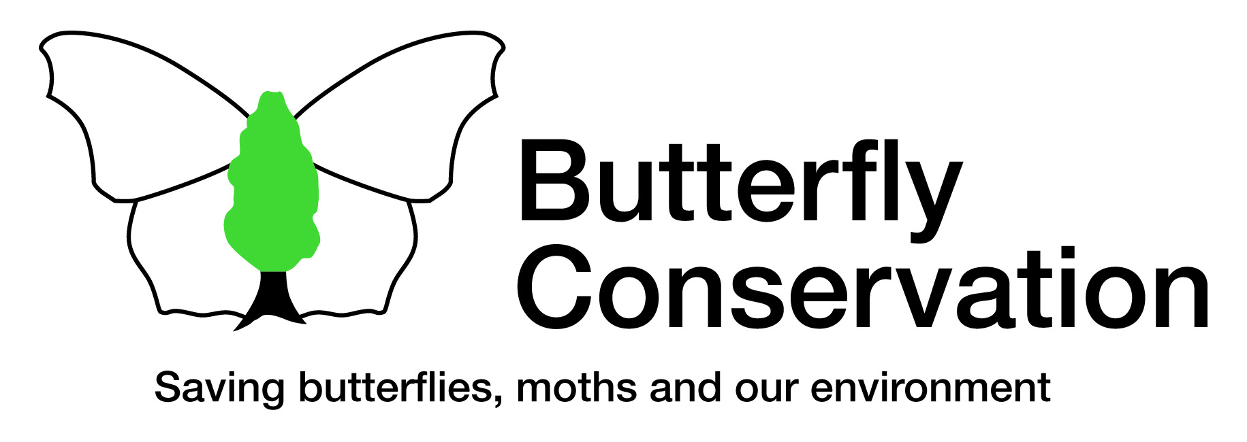
Branch Treasurer
Location: | Home based but may involve some travel to local meetings.
Purpose of role: | To ensure that the Branch monitors its financial situation and is able to meet the costs incurred by its activities.
Key Contact: | Head of Finance
Tasks: | - Work with the Branch Committee to prepare an annual budget of income and expenditure for the Branch. You may also be asked to advise the committee on the financial implications of their activities.  - To act as a link between the Branch and Head Office (HO) for all financial matters on a regular basis.  - Review financial reserves required for the Branch.  - Provide authorisation to the Head Office Finance Team for invoice payments.  - Provide HO details of any income paid directly into the bank account in a timely manner.  - Provide HO with the information required to complete end of year processes.  - Maintain a list of branch equipment for insurance purposes.
Dates, times, commitment and frequency: | This role is active year-round. Budgets for the following year are prepared in the first few weeks of April.  This role can be done from home at a time that suits you.  We ask for a minimum commitment of 6 months. Typically, the role takes a few hours a month but this will vary according to how active your branch is.
Skills and abilities needed: | - Experience of working with numbers and using spreadsheets is desirable – or a willingness to learn.  - Organised and efficient with an eye for detail.  - It is helpful to have good written and verbal communication skills for this role.  - You will be able to use spreadsheet software such as MS Excel and will need access to the internet and email.  - You do not need to know about butterflies or moths for this role.  - Your behaviour will support Butterfly Conservation’s values.
Benefits and support provided: | In addition to the many general benefits of volunteering with us, this role also provides the opportunity to:  - Develop and demonstrate your financial skills in a professional environment.  - Work with other members of your local Butterfly Conservation branch and find out more about our work.  - Use or develop transferable skills such as: communication, working with other people, planning and financial management.

